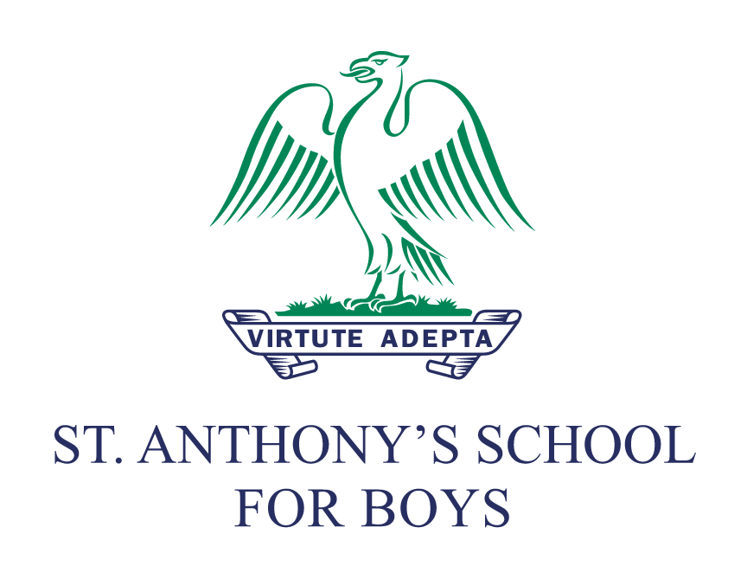
Photos and Images Policy

Policy reviewed by CA
Review date: July 2021
Submission: July 2021
Policy actioned from: September 2021 – August 2022
Next review date: July 2022
Reviewer’s Signature: CA
Head Teacher’s Signature: RPB

Circulation: This policy has been adopted by the governors, is addressed to all members of staff and volunteers and is available to parents on request. It applies wherever staff or volunteers are working with pupils.
Please note: ‘School’ refers to St. Anthony’s School for Boys ‘parents’ refers to parents, guardians and carers.

Contents
- Scope and definitions
- General principles for staff
- Safeguarding
- Data Protection Act
- Photography and image capture in school
- Photography and image capture by parents
- Photography and image capture by pupils
- Publicity
- Monitoring

Appendices
- Parental Permission Letter

Scope and definitions

The purpose of this policy is to set out general rules about the capture and distribution of images and photographs of children and to give staff and parents guidelines on the subject. It applies to activities on school premises or as part of off-site events or trips.

“Image capture”, “photography” and “videoing” refer to any kind of image capture, still or moving, obtained by any photographic device including still image cameras, video cameras, webcams and photographic enabled mobile telephones, and any other type of image capture device not specified here, whether digital or not, using technology existent at this time or in the future. The storage of such images includes film negative, film positive (e.g. transparencies and slides, movies, etc.), photographic paper, digital media, magnetic tape and any other kind of storage method able to be used for the storage of images, still or moving, available now or in the future.

This relatively short policy is part of our strategy for safeguarding children within our care. It complies with Keeping Children Safe in Education (KCSIE) 2020 and should be read in conjunction with our other policies, notably:
- E-safety
- Mobile Phones and Personal Electronic Devices
- Safeguarding
- Anti-Bullying (including cyber-bullying)
- ICT Usage
- PSHEE
- Social Media

General principles for staff

Every reasonable effort must be made to minimise risk of inappropriate capture and distribution of photos and images. This includes:

- securing parental consent for the use of images of their children
- not using photographs of children or staff who have left the school without their consent
- ensuring that children and staff are appropriately dressed
- ensuring that children’s names are not used alongside images in publically-available material
- not using an image of any child who is subject to a court order;
- storing images securely and accessible only by those authorised to do so
- storing images securely (whether physical or digital) with appropriate access controls
- ensuring staff are appropriately informed about this policy

Safeguarding

There may be a risk to the welfare of children when individual children can be identified in photographs. For that reason, we have developed this policy to make every effort to minimise risk.

Where the capture or distribution of images of children raises a safeguarding concern, the Designated Safeguarding Lead (DSL) must be contacted immediately. Further details on safeguarding procedures are available in our Safeguarding policy.

Data Protection Act

Photographs and video images of pupils and staff are classed as personal data under the terms of the Data Protection Act 2018. Therefore, using such images for school publicity purposes requires the consent of either the individual concerned or in the case of pupils under 13, their legal guardians. In line with the Data Protection Act, everyone responsible for using data has to follow strict rules called ‘data protection principles’. They must make sure the information is:

- used fairly and lawfully
- used for limited, specifically stated purposes
- used in a way that is adequate, relevant and not excessive
- accurate
- kept for no longer than is absolutely necessary
- handled according to people’s data protection rights
- kept safe and secure
- not transferred outside the UK without adequate protection

Photography and image capture in school

Images of children may be captured as part of the educational process. Recordings of pupils for school purposes will only ever be taken using official school equipment or by a designated external professional. Staff must not take or transmit any recording of pupils on any personal device. Staff should also be aware that taking photographs of colleagues using personal devices should only happen with the permission of that member of staff.

Images of pupils or staff must not be displayed on websites, in publications or in a public place without specific consent. The definition of a public place includes areas where visitors to the school have access. Where photographs are taken at an event attended by large crowds, this is regarded as a public area so it is not necessary to get permission of everyone in a crowd shot. However, every effort will be made to inform attendees that photographs are being taken (for example, through signage).

On occasions, commercial video films may be made of children on educational visits and performing in school productions. The school will inform parents where arrangements have been made for a commercial photographer to film such an event.

Parents’ media permissions must be kept on file (see parental permission form at the end of this document). They will be processed in line with Alpha Plus Group’s Privacy Notice, which is available on request or can be accessed via the Group’s public portal.

Photography and image capture by parents

As a general rule no parent or visitor is permitted to use a camera (including a mobile phone’s camera facility) whilst on school premises. However, the Data Protection Act does not apply to photographs or films taken for personal use by family and friends and it is usual for parents to want to take photographs and videos of children at school events.

Exceptions to this rule are therefore made for some specific events such as plays, recitals, concerts, sporting events, open days or other promotional events. We strongly advise parents against the publication of any such photographs on the internet (e.g. on social media), and we will request parents to remove any such material if we deem it illegal, harmful or inappropriate in any way.

Where appropriate, our policy regarding this matter should be explained clearly to parents by a member of staff before difficult situations arise.

Photography and image capture by pupils

Staff will supervise and maintain control over any photographing or recording that pupils do during on-school or off-site activities.

Publicity

Schools need and welcome publicity. Children’s photographs add colour, life and interest to articles promoting school activities and initiatives. Making use of photographs for publicity materials and to promote the school in the press can increase pupil motivation and staff morale, and help parents and the local community identify and celebrate the school’s achievements. However, photographs must be used in a responsible way. Schools need to respect children’s and parents’ rights of privacy and be aware of potential child protection issues.

Monitoring

It is the responsibility of all school staff to support and monitor this policy. Any concerns should be brought to the attention of the Head.

Appendix 1 – Parental Permission Letter
Dear Parents,
Media Permission
The use of digital media is an integral part of the curriculum and we are proud to be at the forefront in the use of the latest technology in the education of our pupils. This ensures that your children are prepared for the challenges of working and learning in the twenty-first century. All activities across the school now make use of a wide range of digital media. As a part of this usage, from time to time the pupils will be recorded (in a range of formats). This is a fundamental part of your child’s learning and assessment throughout her school career. We are seeking your permission to store and use these recordings within the school community. For example, photographs might be used in exercise books, on display boards or in the school newsletter. To ensure maximum security for all pupils, no personally identifiable information will accompany these recordings when they are displayed.
Without this permission, your child will be unable to take part in a number of school activities. This permission will be valid for your child’s school career with us, although you have the right to change this permission at any time in writing.
In addition to the strictly internal use mentioned above, there are times we would like to be able to share pupils’ achievements with a wider audience beyond the school. We are very proud of the achievements of our pupils and occasionally we like to share these achievements with a wider public audience beyond the school community. For example, we would like the opportunity to share photographs on the school website, alumni site or on the school’s official social media channels.
We are therefore seeking your additional permission to use recordings (photographic or other formats) of your child for promotional purposes.
-------------------------------------------------------------------------------------------------
Please return this slip to the School Office:
I give permission for my child to be photographed and videoed for school purposes (in exercise books, on display boards, in the school newsletter, school website, alumni website and the school’s official social media channels).
Yes/No

I give permission for recordings (photographic or other formats) of my child to be used for promotional purposes (eg marketing materials, school website) Yes/No

I give permission for photos of my child to be used on social media Yes/No

I understand that no personal information will be linked to any photographs or videos.
Child’s name: _______________________________Year: ________________
Parent’s signature: _______________________________Date: _____________________
Please PRINT Name: ______________________________________________________

If you are not happy for us to use your child’s image for this purpose, please indicate by putting an X in the box below.

We reserve the right to prohibit the use of cameras for some events if deemed inappropriate by staff.

